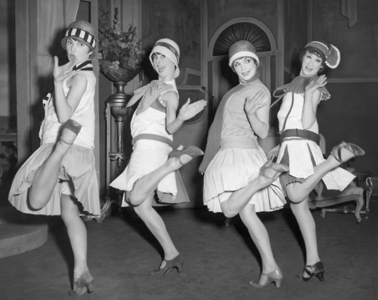

All that Jazz!

The 1920s were an exciting period in American history, complete with numerous social changes and cultural conflicts. For this assignment, each of you will research and create a poster on a topic related to the 1920s and the novel, The Great Gatsby. You will also use your information to write a brief one-page analysis of your topic and how it compares to life today. Then, each student will participate in a Gatsby party/gallery walk and view all of the posters. This will count as SIX grades: Research (Information & Source Evaluation 50 points), Poster Sketch (25 points), Poster (200 points), Connection to society response (30 points), Self-Reflection Paper(30 points), and Gallery Walk (15 points). The poster and written pieces will be summative grades and the others will be formative grades.

HOW TO BEGIN:

Conduct research on your topic by using print resources and the Internet, focusing on the 1920s.

Break your topic into **three** **subtopics** that you will research. This will help you focus your research. Here’s an example: If my topic is New York City during the 1920s, three subtopics could be: Immigration in the city, the role of the media in NYC at this time, and the city as an industrial center.

You need at least **THREE different sources** for your works cited. No Wikipedia. One of your sources must be from either a book or a magazine. You will need to submit a source validation sheet for each source.

Find **TEN pieces of information** **for each subtopic**. These can be facts, statistics, quotes, anecdotes, or anything you find interesting.

the writing portion:

Now that you have researched your topic, I want you to think about how your topic relates to today’s society. Make connections. For example, if your topic is the Black Sox scandal, how are elements of what happened seen today? This should be a minimum of 2-3 well developed paragraphs. This will be submitted to turntin.com. **Credit will not be given on poster unless this is submitted. The written portion is just as important as the art.**

You will also complete a self-reflection essay. See example for instructions on how to complete this.

* Create a visually pleasing poster using your research.
* Make labels for each of your subtopics.
* You may type or handwrite the information, using short paragraph style chunks.
* Your poster must be poster board. NO neon board.
* You must have at least **four photos**, graphics, or illustrations for your poster. These must be mounted.
* No staples, tape, or glue should be seen on your poster.
* Each picture needs a caption identifying what (and who) is being shown.
* Your poster must have a headline stating your topic, readable from three feet away.
* Your poster should be interesting and creative, but keep your creativity related to the topic. For example, if your poster is on Prohibition, glitter glue flower designs are not appropriate.

The Nitty-Gritty:

1920s poster project

Mrs. Fields-English III

**Your sources:**

One of your sources must come from **books or magazines.** The other two (and more if you like) can come from a website.

The sources must be listed in proper MLA style on the bottom right corner of your poster. This must be typed, even if the rest of your poster is handwritten.

Your information sheets are not to be placed on your poster.

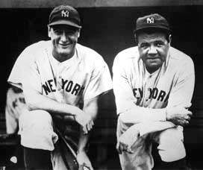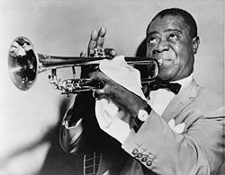

See this white boarder around the photo? To get this look on your poster, you mount the picture on a piece of colored paper. This makes the photo stand out more on your poster. Every picture must be mounted.

Make sure the images are of good

quality that you use. If the image

looks blurry, don’t use it.

Sketching your poster really does

help you before you begin. Make sure you complete the planning sheet and get it approved before you begin.

Have fun and be creative!

Perhaps you want all text mounted

with one color and photos in another?

Or each subtopic mounted in the same

color? Make these decisions before

you start.

Have fun with your title. Make sure it

conveys what you need it to convey

about your topic. Most importantly,

make sure we can read it.

Need help designing your poster? Here are some tips:

by The Green Light

Your English Teacher

• • •

Think first about what you want to convey with your poster. The design you create will also help the viewer understand your topic.

What color poster board works best for your poster? Don’t pick a color just because you like it. Make sure it fits.

You need a minimum of four images on your poster. Make sure all of the pictures are not the same size. One picture should be dominate -- the main picture.

Use the space on the poster wisely. Don’t pockets of empty space. This being said, make sure there isn’t too much stuff on your poster so we can read the information.

Mounting your text and your pictures is a good way to make them stand out. Be specific in how you do this. Perhaps you want all text mounted with one color and photos in another? Or each subtopic mounted in the same color? Make these decisions before you start.

Have fun with your title. Make sure it conveys what you need it to convey about your topic. Most importantly, make sure we can read it.

Make sure the images are of good quality that you use. If the image looks blurry, don’t use it.

Sketching your poster really does help you before you begin. Make sure you complete the planning sheet and get it approved before you begin.

Have fun and be creative!

By the numbers: The Assignment Breakdown

Make sure you follow the number guidelines and have **THREE subtopics** and have at least **TEN pieces of information for each subtopic.**

There are four separate grades for this project worth a total of 360 points. This will be a huge percentage of your second trimester grade. Do your best work and submit on time!

— Urna Semper, Ipsum

Subtopics 3

Facts per subtopic 10

Sources required 3

Minimum # pictures 4

Connection to society 1

Self- Reflection 1

# of grades for project 6

Total points 350

pictures: mounted & Captioned

Every picture you use on your poster MUST have a caption explaining the image. No caption = no credit.

